Home Work 7

1.

A Journey of a Thousand Miles Must begin with a Single Step.

2.

#include <stdio.h>

#include <conio.h>

struct PlaneTicket

{

char Name[100];

char Destination[100];

float TicketPrice;

};

struct PlaneTicket b1={"Monir","Bombay",22000.25};

struct PlaneTicket b2={"Sharmin","Bangkok",12500.75};

main()

{

printf("\n The details entered for the Structure PlaneTicket is");

printf("\n For the first variable is");

printf("\n Name is %s",&b1.Name);

printf("\n Destination is %s",&b1.Destination);

printf("\n Price is %f",&b1.TicketPrice);

printf("\n For the Second variable is");

printf("\n Name is %s",&b2.Name);

printf("\n Destination is %s",&b2.Destination);

printf("\n Price is %f",&b2.TicketPrice);

getch();

}

Output:

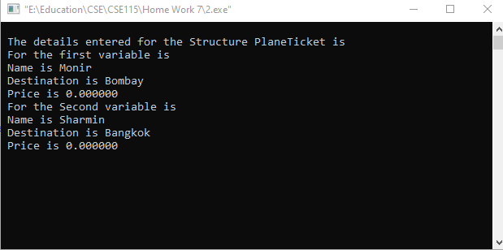

3.

#include <stdio.h>

#include<string.h>

typedef struct Student {

int StudentId;

char name[50];

float CGPA;

char Major[20];

}stdnt;

struct Student HighestGPA(stdnt st[]){

for(int i=0;i<3;i++)

if(st[i].CGPA > st[0].CGPA)

st[0] = st[i];

return st[0];

}

int main(int argc, char \*\*argv)

{

stdnt st[20];

for(int i=0;i<3;i++) {

printf("enter %d Student id : " ,i);

scanf("%d",&st[i].StudentId); getchar();

printf("enter %d Student name : ",i );

gets(st[i].name);

printf("enter %d Student cgpa : ",i );

scanf("%f",&st[i].CGPA);getchar();

printf("enter %d Student major : ",i );

gets(st[i].Major);

}

stdnt st1 = HighestGPA(st);

printf("Highest Cgpa Holder : \n Name :");

puts(st1.name);

printf(" id : %d\n" , st1.StudentId);

printf("Major: ");

puts(st1.Major);

printf("Cgpa : %.2f" , st1.CGPA);

return 0;

}

Output:

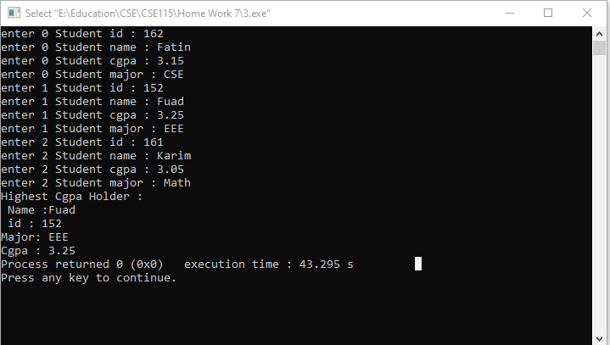

4.

#include <stdio.h>

#include <string.h>

int main( )

{

char str[100];

char vowel[] = {'a','e','i','o','u'};

puts("Enter String :");

gets(str);

for(int i=0;i<strlen(str);i++)

for(int j=0;j<5;j++)

if(str[i]==vowel[j])

str[i]='#';

puts("modified string: ");

puts(str);

return 0;

}

Output:

